**Australian Bushfires WebApp - Project-II Proposal Document**

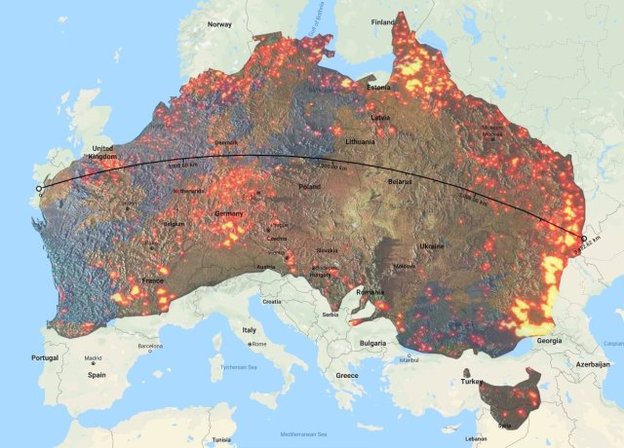

**PURPOSE**: Bushfires in Australia are a widespread and regular occurrence that have contributed significantly to moulding the nature of the continent over millions of years. Bushfires have killed approximately 800 people in Australia since 1851, and [billions](https://en.wikipedia.org/wiki/1,000,000,000) of animals. The purpose of this project is to dig deeper into the roots of current and historical bushfires in Australia and present our findings and analysis results in the form of a web based Flask app with routes for - Australian bushfire locations, global bushfire locations, current and historical fire counts, impact caused by bushfires and climate’s role in causing the bushfires.

Wishlist item: API for accessing our data (depending upon the time availability).

**HOME PAGE**

A cover page providing quick links to the routes. It will also include some important text information about the Australian Bushfires.

**FIRE MAPS**

Australia’s Map with Fire Locations (current and historical)

World Map with Fire Locations

**FIRE COUNTS**

This page will show the current and historical fire counts for the major Australian states (in the form of a graph and/or table).

**IMPACT**

Details of impacts caused by the Australian bushfires. Based on availability of data, this page will be further divided into sections or routes for impacts on wildlife/ environment/ people etc.

**CLIMATE FAILS**

The purpose of this page is to establish a correlation between Australian bushfires and climate by representing the detailed analysis results in the form of plots.

**ABOUT**

About page will be concluding our web page. It will include the reason why we chose this topic for our project, what were our findings, what data sources we used and it might include a wish-list item of API routes to our project data.